PROJECT STORY
Building a Place to Learn
Jedidiah Trust’s Australian Aid–funded Education for Hope project
Jedidiah Trust Zimbabwe | Norton | [24 June 2026]
For most children, a small chair, a shelf of books and a bright room are simply part of growing up. For a child whose parent is in prison, they can be out of reach.
With support from the Australian Government's Direct Aid Program (DAP), Jedidiah Trust is changing that through our Education for Hope project. DAP has helped us refurbish and furnish a nursery classroom at Chikurubi Female Prison, open an Australia Learning Corner in Norton, print trauma-informed "Feel to Learn" workbooks, and hold "Let's Talk" sessions where children can share how they feel.
These are more than rooms and books. They give children a safe place to learn, the adults who care for them better ways to support them, and families a reason to hope.

Why this project matters
Children of incarcerated parents are among the most overlooked children in any society. They did nothing to cause their situation, yet they often carry its heaviest consequences: stigma, disrupted schooling, strained family finances and the quiet grief of separation from a parent.
In Zimbabwe, these children live in two very different circumstances. Some spend their earliest years inside a correctional facility with their mothers. Others are left behind in communities, cared for by grandparents, relatives or neighbours who are often struggling to provide for them. In both situations, a child’s chance to learn and to heal depends heavily on the space around them.
Our work rests on a simple belief: education and emotional wellbeing cannot be separated. A child who feels safe is ready to learn, and a child who is learning is building hope. Education for Hope was designed around that belief.

About Jedidiah Trust
Jedidiah Trust Zimbabwe is a registered nonprofit (Reg. MA1726/19) based in Norton. Since 2019 we have supported children of incarcerated parents, their caregivers and imprisoned parents through psychosocial support, education assistance, caregiver empowerment and family reintegration. We work with the blessing of Zimbabwe Prisons and Correctional Services (ZPCS).
In 2025 alone, our programmes reached 1,240 children and 420 caregivers, and 92% of the children we support stayed in school. Education for Hope builds on that experience and gives it two new physical homes.

Our goal and objectives

The goal
The goal of Education for Hope is to empower children and families affected by incarceration in Zimbabwe by improving access to education, promoting emotional healing and strengthening the environments in which these children are cared for and taught.
To reach two overlapping but underserved groups, the project uses a dual approach: one set of interventions inside a correctional facility for children living there with their mothers, and another in the community for children left behind when a parent is imprisoned.

The objectives
The project set out to:
- Create child-friendly learning spaces inside a correctional facility and within the community.
- Provide trauma-informed learning tools that help children process difficult experiences.
- Offer psychosocial support so that children have a safe place to talk.
- Deliver transparently with careful monitoring, documentation and reporting.

What this support has made possible
A new start for the nursery at Chikurubi Female Prison
At the heart of the project is a nursery classroom at Chikurubi Female Prison, where young children live with their mothers. The room needed real work before it could be a place where small children could safely play and learn. With DAP's support, it now has new flooring, a repaired ceiling, brighter lighting and better airflow, making it a warmer, safer and more welcoming space.
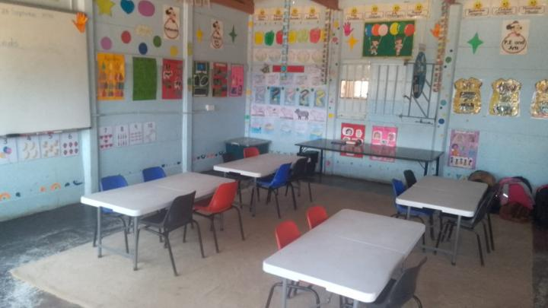
The room is now furnished with furniture made for small people, so that children can sit comfortably, reach the shelves and learn with good posture. The shelves give books and learning materials a proper home, the cabinets keep educational and psychosocial materials secure, and the mats give children a warm surface for floor-based play and story time.
Part of the refurbishment labour was carried out by inmates under skilled supervision. This kept costs down and gave the people closest to these children a hand in creating a better space for them.

The Australia Learning Corner in Norton
Not every affected child lives in a prison. Many are in the communities around us, and they too need somewhere welcoming to learn. At our offices in Norton we have established the Australia Learning Corner, a child-friendly space fitted with child-sized chairs, tables and sheklves.
The Learning Corner is being used for reading and homework support, workbook sessions, psychosocial activities and caregiver meetings. It gives children who often have nowhere quiet to study a consistent, safe place to learn, and it gives caregivers a place to connect and find support.

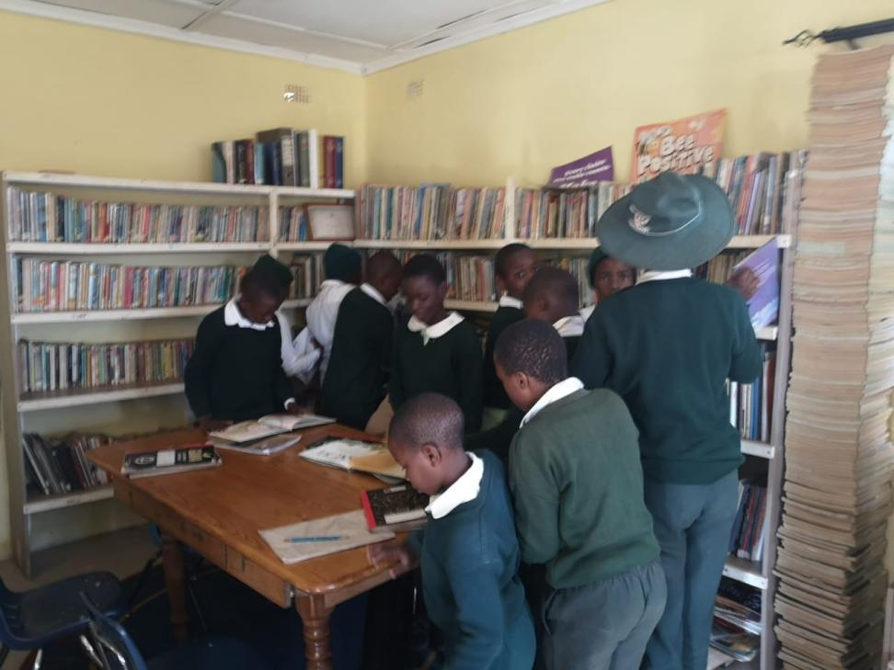

“Feel to Learn”: workbooks that help children heal
Furniture and shelves make a good learning space. What happens inside it matters just as much. We have developed and printed “Feel to Learn” trauma-informed workbooks, and we are working with children to put them to use.
The workbooks are part of the Feel to Learn psychosocial curriculum, a 20-unit programme for children aged 5 to 17 that Jedidiah Trust has developed for children affected by a parent’s incarceration. Trauma-informed means the exercises are designed with the understanding that difficult experiences shape how children feel, behave and learn. Through guided, healing-focused activities, children are helped to recognise and name their feelings, to feel less alone with them, and to rebuild confidence in themselves and in learning.

“Let’s Talk”: giving children a voice
Children rarely get to talk openly about what it is like to have a parent in prison. So far we have held three Let’s Talk psychosocial sessions with refreshments to make the setting relaxed and welcoming. The sessions offer a safe, supported space to share feelings, to hear that other children have similar experiences, and to begin to feel understood.
On-site orientation and technical mentoring are built into delivery, so that the staff, volunteers and caregivers who work with these children are better equipped to continue the work.
“When children are given a safe place to learn and grow, you can see hope return to their lives.”
— Facilitator

What we are learning
Three lessons stand out so far:
- Partnership makes access possible. Our relationship with ZPCS means we can work inside the prison with trust and cooperation.
- People matter as much as products. Involving the prison community in the refurbishment has given the project local ownership.
- Space and support work together. A well-equipped room is most powerful when it is paired with trauma-informed tools and people trained to use them.

What comes next

Education for Hope shows what is possible, and there is much more to do. Many more children, inside prisons and in communities across Zimbabwe, are waiting for a safe place to learn. We hope to work with new partners to take this model to other prison nurseries and communities, and to keep growing the Feel to Learn programme so that more children can benefit from it.

Thank you
We are deeply grateful to the Australian Government, through the Australian Embassy in Harare and the Direct Aid Program, for believing in this work and supporting it. We also thank Zimbabwe Prisons and Correctional Services for their cooperation, and the staff, volunteers, suppliers and community members who are helping us deliver every part of the project.
Most of all, we thank the children and families who remind us why this work matters.

Get involved
Do you want to help more children of incarcerated parents learn, heal and thrive? You can support our work in several ways: [donate at (https://jedidiahtrustzim.org/donate/)], volunteer with us, or partner with Jedidiah Trust to extend this work to other communities. Contact us at [jedidiahtrustzim@gmail.com / +263716497900] or visit [www.jedidiahtrustzim.org].

